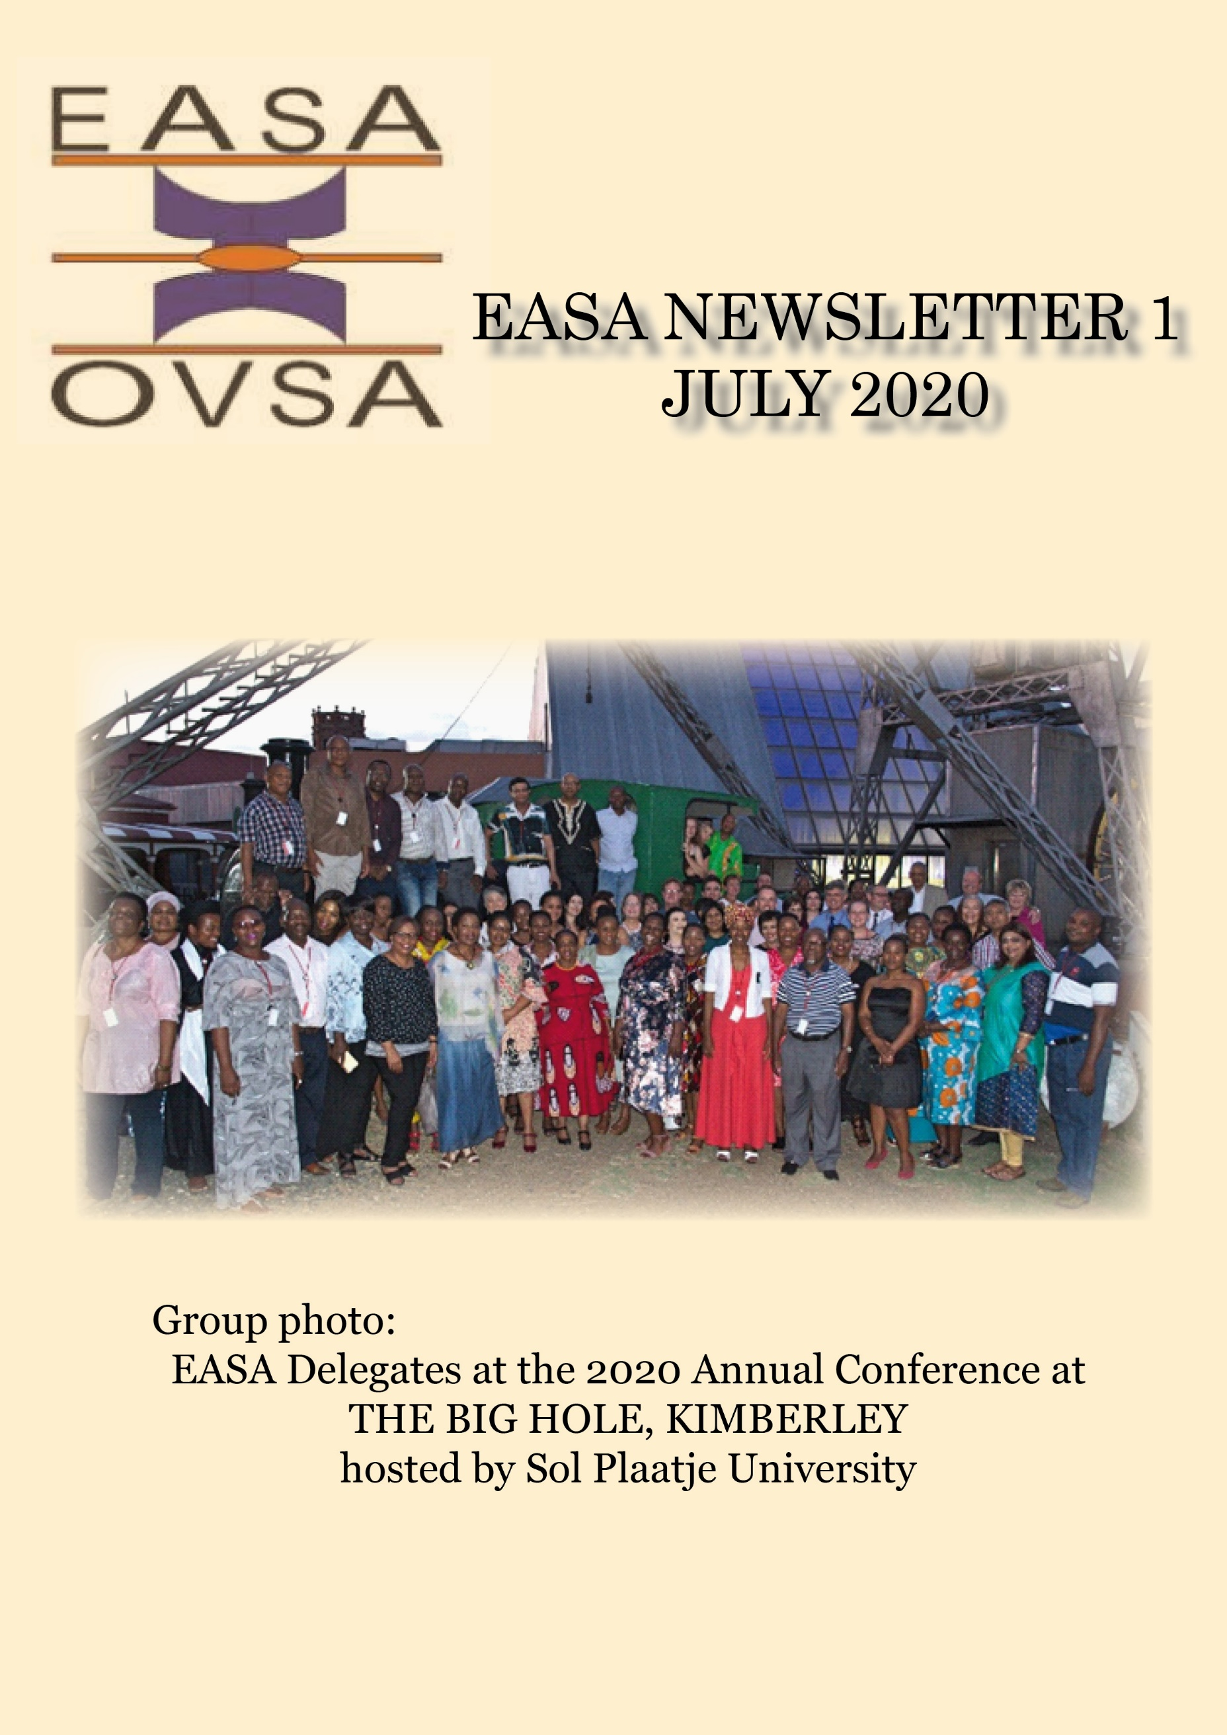

**Table of Contents**

1. THEME: BIG HOLES AND BLACK HOLES: METAPHORS FOR RESEARCHING EDUCATION 3

2. EDUCATION ASSOCIATION OF SOUTH AFRICA (EASA) Chairperson’s report 2019 4

3. Message from the Secretary: Prof Johnnie Hay 6

4. Introducing the 2020 EASA Executive 7

5. Keynote Speaker – Dr P Denley 8

6. Keynote Speaker – Prof L Conley 9

7. Keynote Speaker – Dr HK Kuchah 10

8. Report by Conference Chairperson 11

9. 2020 Conference Photos 13

10. AWARD: EASA POST GRADUATE MEDAL (Doctoral Degree) 16

11. AWARD: EASA POST GRADUATE MEDAL (Master’s Degree) 17

12. AWARDS: EASA Research Medal 2020 18

13. AWARDS: EASA Medal of Honour 2020 19

14. Special Interest Groups (SIG) 20

15. WERA 21

16. Finances and Membership 22

17. EASA 2021 Conference News 22

# THEME: BIG HOLES AND BLACK HOLES: METAPHORS FOR RESEARCHING EDUCATION

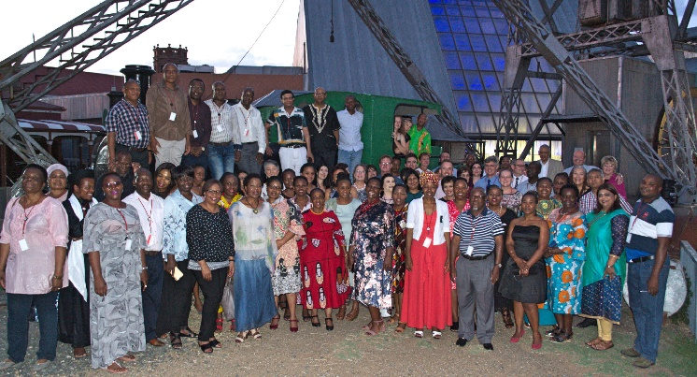

**Background information:**

Kimberley, the host town for EASA 2020 is home to ‘The Big Hole’, the largest hand-dug excavation in the world at a depth of more than 200m. Equally, in space, a Black hole is a fascinating scientific phenomenon with a powerful gravitational force that even prevents light from escaping. Whether a hole on Earth or a theoretical possibility in space, a Big/Black hole conjures frightening and exhilarating possibilities. For example, the Kimberley Big Hole yielded some of the most valuable diamonds on the planet and gave rise to a giant industry, the De Beers Group. The Black Hole in space has generated immense interest and research endeavours culminating in the first sources of evidence of its existence. Interestingly, the big Hole is visible from space but the Black Hole in space is not visible.

For the annual EASA conference, the Big Hole and Black Hole, we believe, can serve as metaphors to capture contemporary research in education. There is much that we know and even more that we do not know in and about education. Why is violence endemic in our schools? How can we maximise learning opportunities? Does our research contribute to development in Africa? Will the inequalities in education ever be eradicated? Metaphorically, we can approach research in education as if it is a Big Hole that can be seen and excavated. We can also approach research as if it were a Black Hole, requiring a search for tangible evidence, cooperative efforts, creative thinking and innovative problem solving. Perhaps we will combine both these approaches, as they are complementary and useful and relevant for research in education. It is therefore, fitting, in the town of ‘The Big Hole’, to contemplate and deliberate about the big black hole-like features and effects of our education system.

# EDUCATION ASSOCIATION OF SOUTH AFRICA (EASA) Chairperson’s report 2019

Over the past few years, EASA has succeeded in strengthening its position as education association in South Africa, yet also in establishing networks with international peers who do research in the field. The primary focus remains on providing a safe platform for scholars in Education to present the research they do and receive constructive feedback while building networks for collaborative work in taking Education forward in our country.

As member of the World Education Research Association (WERA), EASA members have been benefiting from international networks and discussions. Prof Ruth Mampane represents EASA on the WERA committee and as in the past, attended two WERA focal meetings during 2019. We also had the privilege of welcoming international WERA council members to the annual EASA conference in Polokwane in January, and could all benefit from the symposium presented by them. Later in the year, three EASA EXCO members were invited to present as part of two WERA symposiums at a conference in Rio de Janeiro, Brazil, discussing inclusive education, social justice, equality and career opportunities in South Africa with peers from similar contexts. As member of WERA, one of the primary focus areas for the next few years is for EASA to strengthen its position in the international field of education research by, amongst other things, more actively taking part in WERA conferences in order to showcase the work done by EASA members, build capacity and strengthen international ties with peers. EASA is proud of the fact that one of our members, Prof Liesel Ebersöhn is the WERA secretary-general, in addition to other EASA members being involved in the association.

In reflecting on the 2019 EASA annual conference, held in Polokwane, high level engagement and in-depth scholarly discussions come to mind. Keynote addresses stimulated dynamic discussions and allowed scholars to share existing research while contemplating new ideas for future endeavours. EASA members also had ample opportunity to network with peers and strengthen existing ties. On behalf of the EASA

EXCO, we would like to thank Prof Jacob Sefara and his committee at the University of Limpopo, for hosting and arranging a memorable conference. We would also like to thank Ms Petra Lawson, a familiar face at EASA conferences, who acted as conference coordinator for the last time in 2019.

In the same manner, we would like to thank Dr Anthony Mpisi and his team from Sol Plaatje University for hosting the 2020 EASA conference, supported by Narina Basson and Marian Louw from Event Behella as conference coordinators. Thank you for bringing EASA to one of the landmarks of South Africa and for introducing us to one of the newest universities in South Africa. We believe this Big/Black hole event will form a distinct landmark in EASA’s history of almost 62 years. We look forward to lively debates over the next few days, to catching up with old friends and building friendships with new ones, and to honouring the 2020 awardees of EASA medals for their significant contributions in Education research.

Despite the challenge we faced at the beginning of the year with the resignation of Dr Eric Eberlein as 2019 chairperson, the EASA EXCO was able to continue with the work of the association and attend to the aims formulated for the year. Following the Annual General meeting in January, EXCO communicated the EASA members’ decision not to merge with SAERA and to remain an individual association. It however remains a priority for EXCO to strengthen ties and communication with not only SAERA (as suggested at the 2019 AGM) but also with other international associations that focus on Education research.

In addition to finalising the discussions with SAERA, EXCO integrated the comments of its members into the Constitution following the AGM, in order to update the Constitution and ensure that it reflects the nature, focus and priorities of the association. Following approval of the last suggested changes at this meeting, the Constitution will be finalised and added to the EASA website.

As you are aware, the EASA website has been a priority for the past few years, currently under leadership of Prof Elize du Plessis. We invite all members to send ideas and information that may add value to the website as this provides a platform for EASA to showcase the work done by its members and the contributions made to Education research in South Africa. In addition, we encourage all EASA members to more actively engage in the recently established Special Interest Groups, as these provide excellent platforms for networking and collaboration.

In terms of the financial position of EASA we are happy to report a positive position. We would like to thank Prof Raj Mestry as treasurer, for taking care of the finances in such a competent way, continually building on what has been accomplished over the years.

In the same manner, the South African Journal of Education has continued to strengthen its position as leading journal in Education research in Africa. The journal is internationally accredited and increasingly attracts submissions by international authors. As a result, the number of general issues was increased over the past two years, with the number of articles per issue similarly moving up. Based on its positive standing and success, SAJE makes a significant contribution to the financial position of EASA.

In conclusion, please allow us to thank the 2019 EXCO members for their contributions and hard work during the year. We would like to specifically thank and honour two seasoned leaders of EXCO, Prof Eldrie Gouws and Prof Anne-Mari Dicker, who have dedicated much of their time to take EASA forward over many years. Even though these two EXCO members indicated the intention to resign from EXCO at the end of 2019, we would like to thank them for agreeing to stay on as additional EXCO members for another year, allowing the remaining members of the committee to learn from them, based on their years of experience and expertise.

We would also like to welcome Dr Fumane Khanare who joined EXCO as additional member, as well as Prof Funke Omidire, who will take responsibility for International Research Networking (IRN) – a newly established portfolio on the committee, as part of the priority to strengthen EASA’s international ties, visibility and acknowledgement of the research conducted by its members. As Prof Omidire is involved in an IRN at WERA, she is in a perfect position to drive this goal. We furthermore welcome Prof Maximus Sefotho as EXCO member for 2020 and would like to thank him for taking on the task of arranging the 2021 conference, supported by his Dean, Head of Department and conference committee. Finally, our best wishes accompany Prof Nyna Amin, chairperson of 2020, to whom we now hand over the reins.

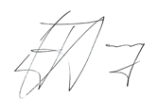

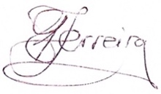_____________________________________________________________________

Ronél Ferreira Eldrie Gouws Johnnie Hay

EASA EXCO Chairpersons 2019

DATE: 13 January 2020

# Message from the Secretary: Prof Johnnie Hay

Just a short paragraph or two from the Secretary's side:

**Prof Johnnie Hay**

**Secretary (NWU)**



It has been a huge pleasure to move over into the Secretary portfolio since the 1st of January 2020 - to continue to serve EASA in a different capacity. Thanks to prof Anne-Mari Dicker who served EASA for many years in this capacity.

Some of the highlights thus far has been attending the EASA 2020 Conference hosted by Sol Plaatje University (Dr Tony Mpisi as Conference Chair) and networking with colleagues there close to the Big Hole, updating our EASA Constitution to be as recent and relevant as possible (available on the website) and supporting prof Du Plessis to continually update our website. Unfortunately, the site has to be changed to a new platform, and since about March we could not really adjust anything. We hope that this will soon be resolved.

We are trying to communicate as well as possible via email, and recently updated our distribution list to also include conference attendees of the last two to three years.

We are also very glad to welcome the following new members who joined after the 2020 Conference:

* Full members: Dr Portia Sifolo from TUT, dr Sarlina le Roux from UNISA, dr Anastacia Mamabolo from Gordon Institute of Business, dr Bernie Plaatjies from FS and Lihle Ndlovu previously from Umfolozi TVET College

* Student members: TH Peloyahae and Lindokuhle Ubisi from UP

I am also glad to report that we had our first virtual EXCO meeting on 8 June - after we moved the March meeting that would have taken place at UKZN, the home of prof Amin, our Chairperson for 2020.

Members - please do not hesitate to contact me iro any administrative issues - [Johnnie.Hay@nwu.ac.za](mailto:Johnnie.Hay@nwu.ac.za)

Kindest of EASA regards!

**Johnnie Hay**

# Introducing the 2020 EASA Executive

**Prof Elize Du Plessis (unisa)**

**SIG and Website Coordinator**

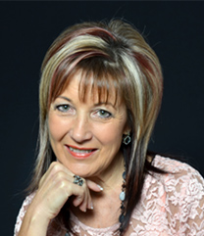

**Prof Ronél Ferreira (UP)**

**Outgoing Chairperson and**

**SAJE Executive Editor**

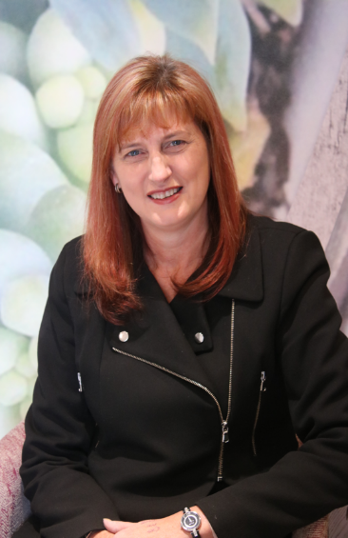

**Prof Raj Mestry (NWU)**

**Treasurer**

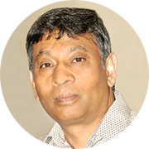

**Prof Johnnie Hay**

**Secretary (NWU)**



**Dr Anthony Mpisi (SPU)**

**Incoming chairperson 2021**

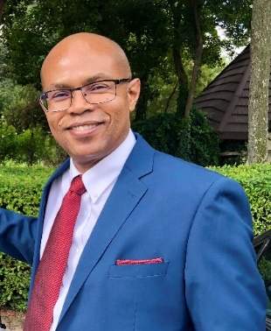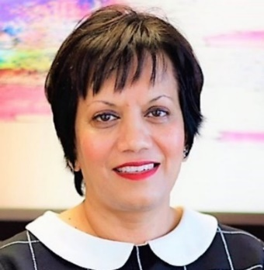

**Prof Nyana Amin**

**Chairperson 2020**

**Prof Eldrie Gouws (unisa)**

**Outgoing Chairperson and**

**Additional member**



**Prof Annemarie Dicker (UNISA)**

**Additional member**



**Prof Maximus Sefotho (UJ)**

**2021 Conference Convener**

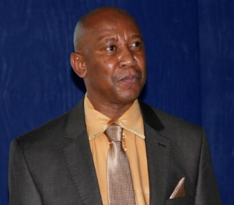

**Dr Fumane Khanare (UFS)**

**Additional member**

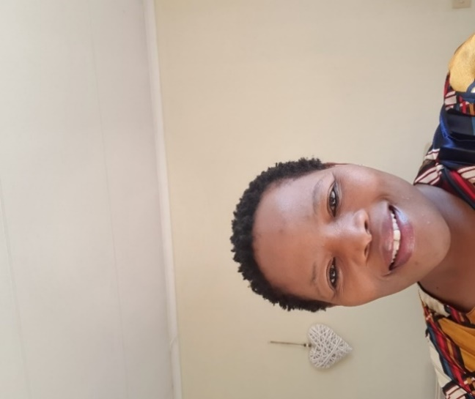

**Prof Mothapule Mampane (UP)**

**WERA Representative**

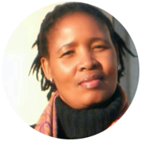

**Prof Funke Omidire**

**International collaboration and**

**postgraduate student involvement**

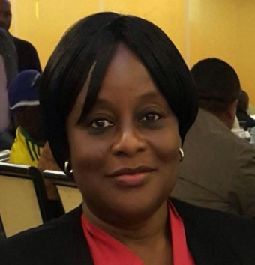

# Keynote Speaker – Dr P Denley



Dr Paul Denley is a lecturer in the Department of Education at the University of Bath. Previously he was a secondary school science teacher and then worked in resource and curriculum development before taking up his position at Bath. His teaching focusses on curriculum, pedagogy and assessment mainly through Bath’s MA Education programme. His research interests are in the professional knowledge of science teachers and in issues relating to language in the science classroom, particularly in multilingual settings.

**Dr Paul Denley**

**University of Bath**

**United Kingdom**

Research interests:

* Development of professional knowledge for science teaching in both beginning and experienced teachers
* Professional development of science teachers; models for professional development; professional development policy
* Issues in secondary science education particularly use of technologies for learning
* Policy and practice in the use of language in multilingual science classrooms
* Curriculum development and assessment in science

Other responsibilities

* Member of the Association for Science Education
* Member of the European Science Education Research Association
* Member of the Southern African Association for Research in Mathematics, Science and Technology Education

Teaching interests

* Science education
* Learning and pedagogy
* Technologies for learning

# Keynote Speaker – Prof L Conley

**Prof Lloyd Conley**

**Executive Dean  
Faculty of Education**

**North-West University**

Prof L Conley has extensive experience in various levels of leadership and management in education, from being Head of Department to Principal of a School, later the director of Education Leadership Institute (ELI) at the University of Johannesburg to being appointed as Executive Dean, Faculty of Education at North West University.

As founding director of the ELI, he faced many challenges and experience remarkable personal and professional growth and development. He obtained skills in visionary leadership and efficient management of staff, programs, infrastructure and facilities; critical thinking and problem-solving; accountability and responsiveness towards people, managing structures and institutions; developing and maintaining relationships with colleagues, stakeholders and project participants; managing finances, corporate governance and risk management; leading with integrity and guided by his values. During his time at the ELI I he also took on additional responsibility with every project that was initiated and successfully completed. The skills and experiences that he has acquired effectively and successfully meet his responsibilities as Executive Dean of the faculty of Education at NWU.

# Keynote Speaker – Dr HK Kuchah

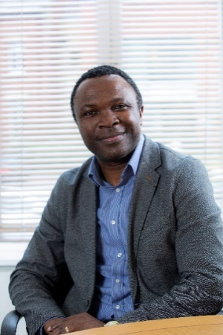

**Dr Harry Kuchah**

**University of Leeds**

**UK**

Dr Harry Kuchah Kuchah is a Fellow of the British Higher Education Academy and Lecturer in Language Education at the University of Leeds, UK, where he also leads the MA TESOL for Young Learners programme. Previously, he worked as an English language teacher, teacher trainer and policy maker in his home country, Cameroon, before moving to the UK. Between September 2011 and August 2018, Harry held teaching and research roles at the Universities of Warwick, Sheffield and Bath in the UK. He has also been involved in a range of teacher education and materials development initiatives in sub-Saharan Africa, South East Asia, South America and Europe. More recently, he has served as a Consultant with the Council of Europe in Albania, with Windle Trust International in South Sudan and with the British Council in Cote d’Ivoire, Senegal, Guinea (Conakry) and Afghanistan. In 2016 Harry was recognised by TESOL International Association as one of ‘30 upcoming leaders’ in ELT globally.

He is currently member of the British Council English Language Advisory Group and President of the International Association of Teachers of English as a Foreign Language (IATEFL). His research interests include Teaching English to Young Learners, English Medium Instruction, Language teacher education and continuous professional development as well as Language education in challenging contexts and he has published substantially in these areas. His co-edited book, International Perspectives on Teaching English in Difficult Circumstances (Palgrave Macmillan) was published in April 2018. He is also co-editor of Ethical and methodological issues in researching young language learners in school contexts (Multilingual matters, forthcoming, 2020).

# Report by Conference Chairperson

Sol Plaatje University (SPU) had both the honour and privilege of hosting the annual EASA conference this year. Although this was a first for the relatively new university, often referred to as the toddler in Higher Education circles, the conference was a resounding success. The conference was held at the Protea Hotel, also known as the Big Hole, with 120 delegates in attendance. Both the location and name of the venue where the conference was held greatly influenced the resolve to appropriately theme it "**Big holes and black holes, metaphor for researching education".**

**Dr Anthony Mpisi (SPU)**

**Conference chair 2020**



Academic papers were focused around the following five sub-themes:

·               Basic education

·               Teacher education

·               Higher education

·               Social justice issues in education

·               Digital education.

The conference succeeded in attracting delegates from various South African public and private universities and beyond.

Day one of the conference commenced with a welcome function on Sunday evening where the Head of School, Prof Audrey Msimanga, rendered the initial receiving of the guests. The DVC, Prof Jean Baxen delivered the welcome address at the plenary session on Monday, where she not only welcomed delegates to SPU, but also challenged them to finding solutions to challenges in Education. Prof Baxen reminded delegates that all spheres of education in South Africa are in flux, with the sector needing to understand and find flexible solutions to multiple and complex education ‘black holes’ that plague the system. Her informative welcome expressed the hope that the conference theme and even the idea of coming to Kimberley provided the delegates the impetus to deliberate on how, as a sector, they could not only pose interesting questions with regards to old problems, but also how they could draw on multidisciplinary, interdisciplinary as well as transdisciplinary work, to understand and respond to educational problems.

The three guest speakers were Prof Lloyd Conley from North-west University, Dr Paul Denley (Barth University UK) and Dr Harry Kuchah (University of Leeds UK). All three speakers delivered thought-provoking presentation.

In his presentation, Dr Denley highlighted the use of metaphor in education and how it can provide an insightful way of developing understanding. He also reminded on how metaphors may provide a different way of looking at educational phenomena to complement conventional approaches.

Dr Kuchah’s presentation was entitled “Towards an enhancement approach to (language) teacher education Sub-Saharan Africa.” He pointed out that despite several years of imported pedagogic principles and practices, classroom realities in most parts of SSA continue to suggest that even the ‘best’ methods are often challenged by lack of student engagement and motivation. He therefore suggested a bottom up enhancement approach to teacher education, where teaching recognises learner, trainee and teacher agency and takes account of the learning context in the process of generating and disseminating good practice. He concluded that within the deep black hole of our educational systems lie the diamonds of pedagogic innovation that are both contextually relevant and legitimate to our cultural realities. Prof Conley reminded delegates about the importance of aligning the learning content with the context of learners.

The conference made provision for excursions and light entertainment purposed to allow the conference delegates to intermingle with hope for future collaborations. These included a tour of the Big Hole mine museum, a tram ride and a tour of SPU’s modern campus facilities. The first day’s events culminated in a sumptuous braai in the SPU library auditorium. On the second day, a gala dinner, which is the highlight of EASA conferences, was held at the Big Hole.

The evening provided for the glitz and glamour, characteristically associated with such an event. The food was divine and the music added to the ambiance of the evening with delegates displaying their dexterity on the dance floor.

The publishing companies, Oxford University Press and Van Schaik, once again played an enormous role in sponsoring the conference. The other funders that contributed to making the conference a success included the Northern Cape Tourist Authority, the British Council, South African Environmental Observation Network, Swift Print, Hancor Dairy, Oranje Rivier Kelders, NTLO Signs and Letlhabile Coaches.

The organising committee comprised of the following academics:

* Dr Anthony Mpisi (Chairperson)
* Prof Audrey Msimanga (HoS)
* Ms Vuyokazi Makubalo (Sponsorship Coordinator)
* Dr Jabulani Sibanda
* Dr Boitumelo Moreeng
* Dr Emma Barnett
* Mr Alan Felix
* Mr Habasisa Molise

The senior management of the university was very supportive and the entire School of Education staff members worked very hard to make this momentous occasion a success. This of course would not have been possible without the unwavering support and meticulous planning of Narina Basson and Marian Louw from Event Behella as conference coordinators.

The conference managed to reach its objective of bringing together thought leaders, academicians and young researchers from around South Africa and beyond to deliberate on critical and persistent issues in education.

Anthony Mpisi

*Chair: Local organising committee*

# 2020 Conference Photos

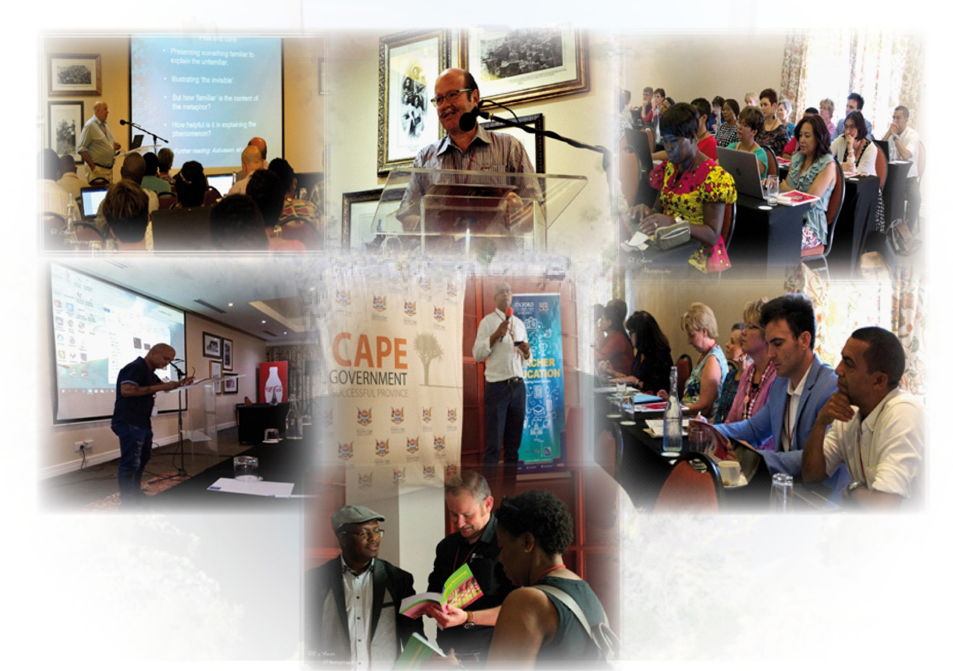

*Presentations*

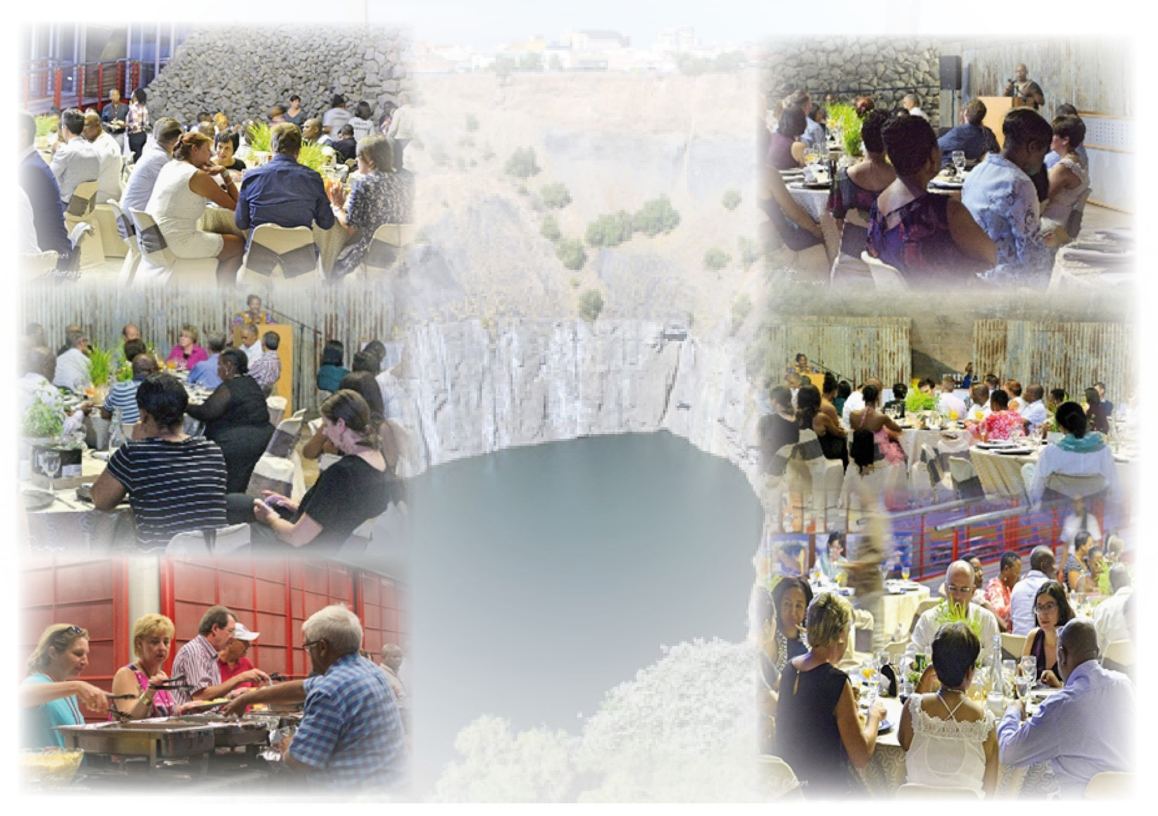

*Gala Evening*

# AWARD: EASA POST GRADUATE MEDAL (Doctoral Degree)

**Dr Nicolaas Blom**



The EASA postgraduate medal (Doctoral) was awarded to Dr Nicolaas Willem Blom, for his outstanding contribution to STEM education in South Africa. His thesis titled Utilising linkography to understand the cognitive mechanisms of technology learners during the design process, did not only demonstrate his scholarliness and exceptional academic potential, but also his ability to conduct and report on ground-breaking research. More specifically, by investigating the incremental development of learners’ thoughts, as they engaged with open-ended engineering design problems to produce novel solutions, he conducted research in a field in dire need of ongoing research, while implementing the emerging methodological approach of linkography in a highly innovative manner. As linkography has not yet been applied with children in the STEM context, the study does not only make (i) a sound theoretical contribution but also provides evidence of (ii) methodological innovation.

Another significant contribution lies in the (iii) practical application value of the model Blom introduces by both pre-service and in-service teachers in the classroom when teaching Technology.

The fact that Dr Blom obtained three external examiners’ reports indicating “No changes required, accept unconditionally” attests to the calibre and quality of the study he completed. In support of this exceptional achievement, some comments made by the external examiners are included below:

* “This work contributes significantly to the technology teacher’s understanding of the complex cognitive processes involved when applying relevant teaching strategies (design thinking processes) when teaching Technology” (national leader in the field)
* “It was an absolute delight to read and I appreciate this kind of work, in technical education in particular. The candidate really applied the technical competencies as expected from those in the technical field within the academic realm, as demonstrated in his thesis. A well-executed piece of work, Mr Blom!” (expert in the field of Technology Education in South Africa).
* “This is highly innovative research in its conceptualisation and execution. Coming to grips with design thinking is a useful topic right now and the use of linkography to understand it makes a valuable methodological contribution” (international leader in the field).

Dr Blom’s doctoral study makes an ontological contribution in terms of the basic structures, mechanisms and events underpinning learners’ design processes. The study contributes to existing literature by providing a novel framework for understanding how learners’ interactions with social, conceptual and physical structures contribute to the emergence of novel design ideas. This is significant as prior studies in design cognition tend to emphasise the development of mental states without acknowledging the role of the social and physical environment, despite the 21st century being marked by an increase in information sources available to designers when solving design problems, and the current emphasis on the 4th industrial revolution requiring that these aspects be foregrounded.

More specifically, Dr Blom’s study illustrates how learners are able to generate thought structures that are often similar to the thought structures of expert designers, in terms of bidirectional thoughts. As indicated, he used linkography to understand learners’ cognition during collaborative problem solving, following data generation by means of Think Aloud Protocol strategies. As a result, he was able to demonstrate that learners incrementally build on each other’s and their own ideas to achieve synthesis in their understanding of a design problem, and their design solutions. The study is soundly embedded in Extended Design Cognition and Activity Systems Theory, and was guided by a mixed methods design, following a critical realist approach.

His study has made and will continue to make a difference in the field of STEM education – in terms of theory building, methodological innovation as well as practical application value. In addition to a journal article currently in the submission cycle, he has published two articles in accredited international journals based on his doctoral study.

# AWARD: EASA POST GRADUATE MEDAL (Master’s Degree)

**Dr Quixi Sonntag**

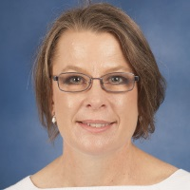

The EASA postgraduate medal (Master’s Degree) was awarded to Dr Quixi Sonntag. In her dissertation, titled Utilising Participatory Reflection and Action to facilitate rabies control in a rural community, Dr Sonntag entered unfamiliar ground by applying qualitative participatory methodology for research in the field of education yet against the backdrop of veterinary sciences, which is often marked by quantitative studies. Being a lecturer herself at the University of Pretoria, Dr Sonntag did not only aim to conduct ground-breaking research that would make a theoretical contribution; she also aimed for positive social change at community level and obtaining findings that can inform community engagement application in the faculties of education and veterinary sciences.

Dr Sonntag’s exceptional work and the scholarliness she displayed in completing the Masters in Education study, has thus infused not only her own but also the teaching and community engagement efforts of some of her colleagues at the University of Pretoria. Based on her study and the findings she obtained, new possibilities for doing research in this particular field have been introduced. As such, her study has not only made a theoretical contribution but also holds practical application value, for both students and community members on ground level. Following her study, Dr Sonntag disseminated the findings of her study as follows:

* Sonntag, Q. (2019). Dog bites – treating the underlying cause of inter-dog aggression. South African Veterinary and Para-Veterinary Congress, Kempton Park.
* Sonntag, Q. (2017). Facilitating rabies control in a rural community – preliminary findings. South African Veterinary and Para-Veterinary Congress, Boksburg.

As a result of the exceptional study she completed and the dissemination of her research, Dr Sonntag has since become involved in an international initiative focusing on community awareness and service provision in the field of veterinary sciences in African countries. She has subsequently developed a concept note with the aim of pursuing a PhD in this field.

After assessing Dr Sonntag’s dissertation, one of the external examiners noted:

*“Thank you to the Faculty and supervisors for the privilege to have been involved in this candidate’s dissertation – dit word hoog waardeer! It made for excellent reading, and kept me highly involved because of the interface between education and veterinary science, and involving PRA. In fact, I found this dissertation to be one of the best that I have examined so far during my career”*

(senior professor at North-West University)

# AWARDS: EASA Research Medal 2020

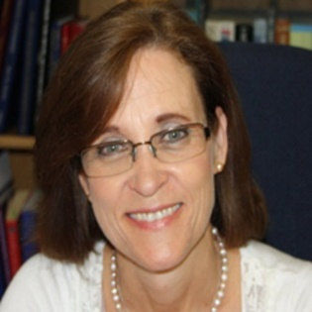

**Prof Elsa Mentz**

The EASA Research Medal was awarded to Professor Elsa Mentz for her consistent achievement in the field of Education in South Africa over the past decades. Prof Mentz is the Director of the Research Focus Area Self-Directed Learning (SDL) at the North-West University. Under her leadership, SDL has grown from strength to strength, and recently the Research Support Committee of the NWU has recommended that the Research Focus Area is upgraded to Unit status. This speaks of visionary leadership. John Quincy Adams once said: “If your actions inspire others to dream more, learn more, do more, and become more, you are a leader”. This is a very apt description of the leadership style of Prof Elsa Mentz. Within SDL she has established a very supportive community of practice, that nurture the scholarship development of post-graduate students and staff.

**Prof Elsa Mentz**

Elsa is a NRF rated researcher (established researcher), and her scholarship centres around self-directed learning and cooperative learning.

Having a strong background in computer science, she also does significant work in blended learning. She is also a leading researcher in terms of the use of Cultural-Historical Activity Theory in research. She is a very productive researcher, and she has published in leading accredited journals such as the International Journal of Mobile and Blended Learning, the International Journal of Lifelong Education, and the African Journal of Research in mathematics, Science and Technology Education, amongst others. (Refer to her comprehensive CV). Prof Mentz has published a number of prestigious books as editor, for example “Self-directed learning research: An imperative for transforming the educational landscape” (AOSIS), and “Self-directed learning for the 21st Century: Implications for Higher Education” (AOSIS). She is often invited to present keynote addresses at international conferences, due to her strong footprint in self-directed learning research.

Prof Mentz has built capacity among young scholars by acting as study leader for a large number of students. To date, eleven (11) PhD and twelve (12) M.Ed students have graduated under her supervision. Currently she supervises five postgraduate students, despite her responsibilities as Director (and acting as Executive Dean from time to time).

She served on the Editorial Board of several respected journals, e.g. the African Journal of Research in Mathematics, Science and Technology Education, the International Journal for Self-Directed Learning, and the Journal of Transformation in Higher Education. Prof Mentz has also championed a Special Interest Group (SIG) on Self-Directed Learning under the auspices of EASA.

She also successfully completed large funded research studies (of which she was the principal investigator), e.g. a NRF research project (with funding of R 2,142,000) on cooperative learning strategies to promote self-directed learning (2014 – 2016), and a SANPAD funded project on empowering IT teachers in economically deprived rural schools (with funding of R 668,000, over the period 2010 – 2013). Apart from the practical contribution of this research (improved teaching and learning practice), she also builds capacity of neophyte scholars, as she involves inexperienced researchers, who she mentors.

If one would ask scholars in the field of self-directed learning (SDL) who the most influential researchers are in the field, the name Elsa Mentz will definitely feature, alongside international leaders such as Lucy Guglielmino and Philip Candy. It is for this reason that we put this nomination forward.

# AWARDS: EASA Medal of Honour 2020

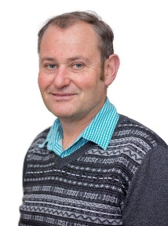Prof Josef de Beer was the proud recipient of the prestigious Medal of Honour for 2020. He is a research professor at North-West University, and holds a C2 NRF rating. He is well known for his high-level achievement in the field of education research. He has 29 years of teaching experience in higher education (three years in the Faculty of Science at the University of Pretoria; the other 26 years in teacher education, at respectively Vista University, the University of Johannesburg, and currently North-West University).

Prof de Beer has published in highly regarded international journals such as the Journal of Curriculum Studies, Research in Science Education, and the American Biology Teacher. In addition, he has also published in local high-impact journals such as the African Journal of Research in Mathematics, Science and Technology Education. He is the co-editor of the acclaimed Pearson publication, Becoming a Teacher, and has recently published an AOSIS scholarly book, titled The decolonization of the curriculum project: The affordances of indigenous knowledge for self-directed learning.

**Prof Josef de Beer**

In addition to his record of consistent publication in renowned academic journals and scholarly books, Prof de Beer’s significant contributions to the field of Education is evident in the numerous awards he has received over the years. These include the HELTASA National Excellence in Teaching award (2009), the University of Johannesburg’s Vice-Chancellors Distinguished award for Teaching Excellence in (2008), and the USA-based National Association of Biology Teachers (NABT) Research award (2012). At his current institution, he has received the award of most productive researcher in the Faculty of Education (external funding) for both 2016 and 2017. Most recently, Prof de Beer received the prestigious 2019 NRF National Excellence in Science Engagement award for his ongoing work and contribution to engaging societies in the natural sciences.

Prof de Beer has successfully supervised 35 post-graduate students (17 Masters and 18 PhD students) to date, at respectively the University of Johannesburg and North-West University. Some of these students have become leaders in education, e.g. Dr Neal Petersen (Director: School of Mathematics, Science and Technology Education) and Ms Lizanne de Villiers, who received the Vice-Chancellors medal for the best Masters study in 2017.

Prof de Beer is an active member of the National Association of Biology Teachers (NABT) in the USA, and received accolades in the form of an Excellence in Life Sciences Research Award in 2012, for his contribution to the Association and the work they promote. He specifically focuses on enhancing the international footprint of NABT.

He has succeeded in securing research funding over the years and has managed funded research projects with great success. He was the recipient of one of twelve national Fuchs Foundation flagship programme awards, to the value of R 2.5 million in 2016. During the period 2016 to 2019, he (and his team members) presented short learning programmes (SLP’s) to Natural Sciences and Mathematics teachers, and workshops to school learners, on indigenous knowledge related to science and mathematics themes, with the ultimate goal of promoting learner interest in STEM themes. The Fuchs Foundation funding (as well as NRF funding: CPRR [98915] and IKS [99014], to the value of R 3 million) made it possible to present these SLP’s and workshops across the country (North-West, Gauteng, Free State, Limpopo, Northern Cape, Western-Cape and KZN), and to also provide teachers with classroom resources.

During the past three years and as a result of his ongoing work in the field, Prof de Beer and his team has provided professional development interventions to around 600 teachers. The impact of this involvement may in turn have affected the lives of thousands of school learners, who may as a result better appreciate the role of science in their everyday lives.

# Special Interest Groups (SIG)

At the EASA 2020 Conference, SIG’s met generally under the facilitation of Prof Johnnie Hay, while Prof Elize du Plessis was on research and development leave. Although attempts were made to keep the SIG’s alive, it was decided in 2019 that the SIG’s will continue mainly for the purpose of networking and sharing information. Members are welcome to join SIG’s and to arrange meetings and activities in their groups. Groups and names of members are available on EASA’s web page. It is a challenge to keep the SIG’s active, due to distance, work pressure, member’s commitments in similar groups and the fact the different members attend the EASA conference yearly. The six special interest groups are:

**Prof Elize Du Plessis (unisa)**

**SIG and Website Coordinator**



Education Management, leadership, Law, Policy Studies, Comparative and International Education; Human Development in Education: Educational Psychology, Early Childhood Education, Movement Education and Inclusive Education; Curriculum Studies’ Philosophy and Sociology of Education and Research Methodology; Social Sciences in Education: Languages, History, EMS and Creative/Performing Arts; Science, Mathematics and Technology Education; and Self-directed Learning.

The EASA webpage is under revision and members can expect a new webpage soon.

Elize du Plessis

*SIG and Website Coordinator*

# WERA

**Prof Mothapule Mampane (UP)**

**WERA Representative**



WERA is an association of major national, regional, and international specialty research associations dedicated to advancing education research as a scientific and scholarly field and EASA is a WERA member. The chairperson of EASA, Ruth Mampane, is a WERA Council member (representing EASA interests). In Southern Africa, and currently as it stands, in Africa, only one education associations (EASA) have council representation in WERA. Education Associations are encouraged to join WERA so that their interests can be represented both nationally and globally. Currently; WERA has approximately 22 council member association representatives. If you want to know more about WERA you can access information from their website (<http://www.weraonline.org/>).

***WERA Officers are:***

**President:** Ingrid Gogolin: [gogolin@uni-hamburg.de](mailto:gogolin@uni-hamburg.de)

**Past President:** Felice Levine, Immediate: [flevine@aera.net](mailto:flevine@aera.net)

**President-Elect**: Mustafa Yunus Eryaman: [yunuseryaman@gmail.com](mailto:yunuseryaman@gmail.com)

**Vice-President:** Joanna Madalińska-Michalak: [Joanna.michalak@onet.pl](mailto:Joanna.michalak@onet.pl)

**Secretary-General:**  Liesel Ebersöhn: [liesel.ebersohn@up.ac.za](mailto:liesel.ebersohn@up.ac.za)

**Appointed Liaison:** Yuto Kitamura: [yuto.kitamura@gmail.com](mailto:yuto.kitamura@gmail.com)

***Feedback on WERA focal meeting Report***

Due to COVID-19 WERA the first Council meeting which was scheduled for April 2020 was cancelled. On the 8th May 2020, virtual (online ZOOM) WERA Council meeting took place. During the meeting, results of the new President were announced as the current (Term of presidency ends on the 30th of June 2020) President, Prof / Gogolin will be Past-President while Dr Mustafa Yanus Eryaman will be President of WERA.

It was decided during the meeting that member associations e.g. EASA will receive communication about possible staggered increase of member fees (what is normally referred to as DUES). This process will be fully explained by WERA executives. The previously planned July 2020 WERA and Sociedad Espanola de Pedagogia (SEP) Conference which was due to take place at Santiago De Compestela in Spain has been postponed to July 2021 due to COVID-19. Please check continuous communication from EASA about calls for papers to attend this conference. Alternatively, visit WERA website for further information and notification on this upcoming WERA conference and other events.

For future planning of conferences, member Associations, including EASA are advised to use the opportunity to request WERA Keynotes and Symposia during their annual conferences, this opportunity is open and available to all member associations. Associations can send an email (WERA@aera.net) or visit the WERA website (<http://www.weraonline.org/>).

WERA website is continuously revamped to ensure maximum exposure. Individual members and member associations are requested to contact the secretariat ([WERA@aera.net](mailto:WERA@aera.net)) with any questions or suggestions regarding WERA. Similarly, EASA members can utilise the opportunity WERA present of international exposure by sending information regarding important events related to EASA. Importantly, members of EASA are encourage to send information to WERA secretariat (Prof. Ebersӧhn: [WERA@aera.net](mailto:WERA@aera.net)) or to EASA-WERA representative: [ruth.mampane@up.ac.za](mailto:ruth.mampane@up.ac.za) regarding all journals (journals used by member associations) for exposure and opportunity for members to have access to multiple platforms for dissemination. The list of journals requested by WERA is not a list of WERA approved journals, but serves to provide a synthesis of journals used by member associations and it provides an opportunity for members to look at regional platforms for dissemination.

**Ruth Mampane**

*WERA Representative*

# Finances and Membership

We calling on all members who have not attended the 2020 EASA conference in Kimberley to kindly pay their membership fees for 2020.

**Prof Raj Mestry (NWU)**

**Treasurer**



New members who are planning to join EASA – you are most welcome to complete a membership form. Annual membership fees is R450, except for student members, who pay R100.

Please make sure that you include your name as reference when making electronic payments.

***Banking details:***

ABSA

Cheque account

Account number 001072 2047

Name of account: EASA/OVSA or Opvoedkunde Vereniging van Suid Afrika

Universal branch code: 632 005

The financial position of EASA is sound. This is reflected in the audited Financial Statements presented to and approved by the Executive Committee.

**Raj Mestry**

*Treasurer*

# EASA 2021 Conference News

The EASA 2021 conference will be hosted by University of Johannesburg. The COVID 19 pandemic has curtailed preliminary planning, but more specific details regarding the conference will be availed soon.