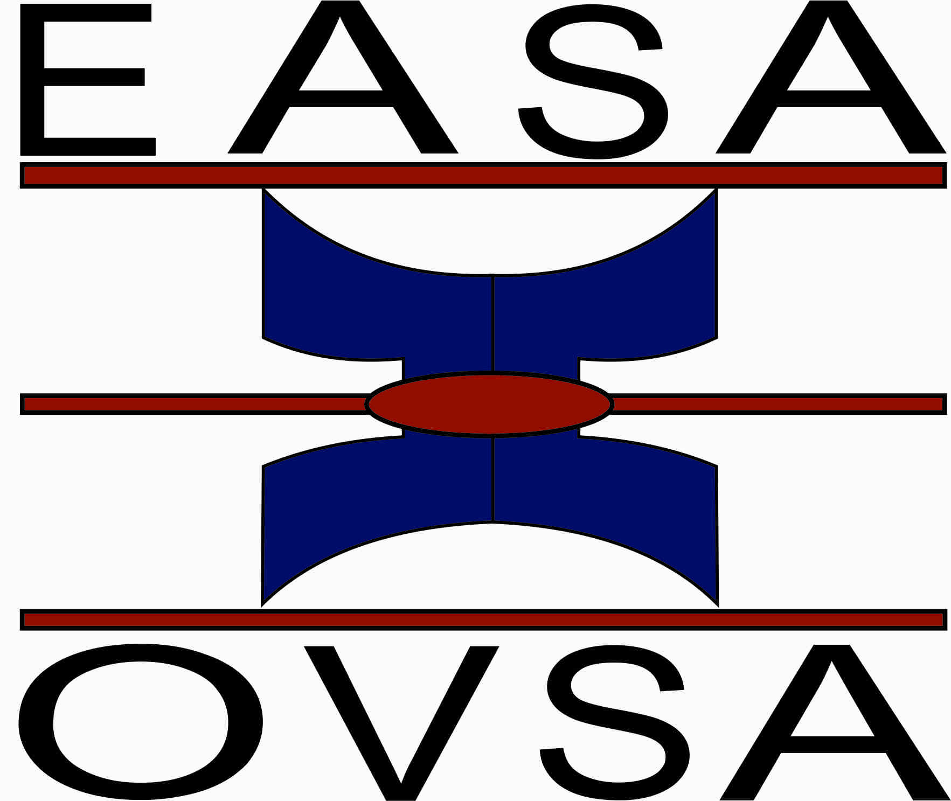

BEROEP OM NOMINASIE CALL FOR NOMINATIONS
for an Incoming-chairperson for the Education Association of South Africa
for the term 2019 (and as member of the EASA executive 2019-2020)

Ke Closing date for nominations: 31 August 2018

Please write a brief motivation for the person you are nominating (not more than 400 words). This motivation should make it clear how EASA would benefit from the nominee's leadership. You will be asked to present this motivation at the EASA general meeting in January 2018.

Please email a scanned version of the nomination form and CV of the person to
Johnnie.Hay@nwu.ac.za

I hereby nominate the following member for the election of vice-chairperson to the EASA management:

Name of nominee:
Office address of nominee:


Email

Proposer:
Office address of proposer:


Email

Signature of proposer:
Date:

Seconder:
Office address of seconder:


Email
Signature of seconder:
Date:

I agree to accept nomination for vice-chairperson for the EASA management and confirm that my fees are fully paid.

Signature of nominee:
Date:

Motivation for nomination:

